Bulgaria’s Secret Empire

Tomasz Kamusella
University of St Andrews

A Very Bulgarian Ultimatum

The year 2019 promised to be a long-awaited annus mirabilis in the Balkans. After the old nationalist guards were replaced with democratic, liberal and pro-European cabinets in Greece and Macedonia, a narrow window of opportunity opened for much needed and long-awaited rapprochement between Athens and Skopje. A bilateral agreement was signed in 2018 and implemented early the following year. The compromise saw the official change of the name of Macedonia to ‘North Macedonia,’ though Athens consented that the Slavic language of Macedonian would continue to be known under its established moniker. On top of that, Skopje opted for the Finnish model of ethnic relations and made Albanian into the country’s co-official language. The domestic tension between Macedonia’s Albanian and Macedonian-speakers finally defused, and Greece no longer standing in the way, the yearned-for prize of membership in NATO and the European Union for North Macedonia appeared to be tantalizingly within a hand’s reach.

However, despite the oft-repeated promises that democratizing reforms would be rewarded with the swift opening of accession negotiations with the European Union, at the summit of the European Council on 18 October 2019, the French President Emmanuel Macron vetoed any such membership talks with Albania and North Macedonia. Paris, as the de facto co-leader of the European Union, alongside Germany, proved to be as unreliable and mercurial as President Donald Trump’s United States. In addition, this move concealed a much darker and much less discussed development of Bulgaria’s ultimatum issued to North Macedonia, four months earlier, in June 2019. For a while the Bulgarian government played down the issue of this ultimatum, by stressing Sofia’s ‘unwavering support’ for North Macedonia’s membership in the EU. Yet, One week before the aforementioned meeting of the European Council, on 10 October 2019, the Bulgarian government led by Prime Minister Boiko Borisov made this June ultimatum into an official Bulgarian policy, fully supported by the parliament. It is a political gift to placate the radical nationalist wing in his cabinet. These nationalists are led by Deputy PM Krasimir Karakachanov, who heads the political party, Internal Macedonian Revolutionary Organization – Bulgarian National Movement. Both this party and its leader infamously espouse openly racist anti-Roma and anti-LGBT rhetoric and even explicit hate speech. A fortnight before the adoption of this ultimatum policy, on 29 September 2019, Karakachanov had directly threatened Borisov by stating that ‘[his party] will leave the coalition, if the government approves North Macedonia’s application for EU membership.’ On 2 October 2019, the ultimatum already secured, Karakachanov opined that ‘all Macedonian politicians […] are good Bulgarians, but publicly they say [the question of the Macedonian national identity] is complicated. The Macedonians think they can enter the EU and keep their anti-Bulgarian rhetoric. This cannot be allowed to happen.’ Having observed negative reactions to the ultimatum in North Macedonia, Karakachanov upped the ante, and on 17 October 2019 strove hard to offend Skopje by pronouncing that ‘North Macedonia is better suited for [joining] the USSR than the EU.’ (The irony is that it was communist Bulgaria which applied twice, in 1963 and 1973, for joining the Soviet Union.)

Bulgaria’s prominent intellectuals and civil society members, shocked by the ultimatum and its authoritarian ramifications, immediately, on 10 October 2019, started a petition against the government’s official position on North Macedonia’s efforts to join the EU. Some see the Bulgarian President Rumen Radev as one of few supporters of democracy and the rule of law in today’s Bulgaria. However, even before the government officially adopted the aforementioned policy on North Macedonia, Radev had approved of this ultimatum almost a month earlier, on 19 September 2019. The Bulgarian President had opined that ‘Bulgaria’s support for North Macedonia’s membership in the European Union should not be detrimental to Bulgarian history, language and identity.’ Then he had followed with a hard demand, ‘If [Skopje] can guarantee that within a month the [Joint Bulgarian-Macedonian] Commission [of Historians] will resolve all the contentious issues – [that is, the nationality of historical] figures, [history] textbook corrections, explanatory texts in [North Macedonia’s] museums, [Skopje’s] views [on all these questions as] presented in the [North Macedonian] mass media, then the Bulgarian government will be in position to pursue a policy of unconditional support for North Macedonia’s membership in the EU. But if [Skopje] cannot provide such a guarantee, the [Bulgarian] government should take concrete measures to include these aforementioned criteria [that is, demands] in the [EU’s] negotiating framework for North Macedonia, as mandatory conditions for [the country’s] membership.’ And that is exactly what happened, when Borisov’s government adopted its official ultimatum policy for North Macedonia.

Democracy in Decline

Paris’s loud ‘Non’ prevented the scandal of nullifying the commencement of membership talks with North Macedonia, due to this Bulgarian ultimatum. As a result, Sofia’s aggressive recalcitrance fell under the radar of Europe’s and international public opinion. The Bulgarian government has been ‘lucky’ in this manner on numerous occasions in the past. Nowadays Europe’s attention has zoomed squarely on the pro-authoritarian and populist regimes in Hungary or Poland, but similar developments escape Brussels’ attention and scrutiny. The same applies to the progressive dismantling of the rule of law in these countries, it is not noticed when taking place in Bulgaria, though causes much international uproar in the case of Hungary and Poland. Obviously, from the European Union’s perspective Hungary and Poland are of much more import for the cohesion of the Union and its structures. But turning a blind eye to the rise of far-right populist ethnonationalist autocracy in Bulgaria with no respect for the law and human rights, may create a monster, which it will be impossible to contain in the future.

Fortunately, on the strength of the 2018 petition addressed to the US Senate, in early 2019, after the hiatus of 15 years, the Bulgarian Service of Radio Free Europe / Radio Liberty was relaunched. This service was originally terminated in 2004, when Bulgaria joined NATO. The freedom of speech in the country’s mass media and public life improved further, when Sofia embarked on a raft of reforms that made it possible for Bulgaria to join the European Union in 2007. But afterward the democratic standards of public discourse were progressively undermined. Media freedom declined. A group of oligarchs with close links to the government took over the country’s main press, radio and television outlets. Alternative and, above all, opposition views have been increasingly incised from public discourse. The necessity of relaunching the Bulgarian Service puts Bulgaria next to such authoritarian states as Azerbaijan, Belarus or Russia. But maybe Bulgarian nationalist see this development as a distinction for their ‘hard graft’ to make sure that Sofia would not ‘bow’ to Brussels. They propose that the EU is the same as the Kremlin’s oppressive Soviet bloc, and NATO is not different from the Warsaw Pact.

Bulgaria’s New Course: Back to the Past

Sofia’s unseemly ultimatum to North Macedonia is a sign of the deepening malaise of democracy in Bulgaria. The old pre-1945 nationalist program of ‘Greater Bulgaria’ is back. The lunatic fringe has now become the mainstream of today’s politics in Bulgaria. Myths and ethnonationalists’ warmongering projects of neo-imperial expansion do away with common sense. In 1989 Sofia expelled 360,000 of Bulgaria’s Turks to Turkey, which destabilized the communist country’s economy, thus precipitating the fall of communist system the People’s Republic of Bulgaria. Afterward these expellees were allowed to return, and two-thirds of them did. Bulgarian nationalists were incensed by this development and demanded that human and political rights would continue to be withheld from these returnees. The existential fear was that postcommunist Bulgaria would break up in the course of an ethnic civil war, like neighboring Yugoslavia. Hence, during the first two decades after the end of communism, all Bulgaria’s main political forces, including the Turkish minority, treaded carefully. They strove to maintain the domestic ethnic status quo, alongside good relations with all the neighboring countries.

However, the success of Bulgaria’s NATO and EU membership encouraged nationalist extremists. In the 2005 parliamentary elections the rabidly anti-Turkish, anti-Roma and xenophobic Ataka (Attack) party won almost a tenth of all the votes. The following year, in the presidential election, over 20 percent of voters cast their ballots for this party’s leader, Volen Siderov. Subsequently, the mainstream parties took over many elements of Ataka’s radical program. The post-Milošević Serbia’s continuing flirt with Putin’s resurgent Russia offered a ready-made model to Bulgarian politicians of how to curry voters’ favor by mixing nationalism with religion as the basis of ‘true Bulgarianness,’ which is capable of standing up to the ‘corrupted west,’ or the European Union. A clear sign of this trend is, beginning in 2001, the institutionalization of the burgeoning posthumous personality cult of the national communist dictator of three decades and half, Todor Zhivkov. Nowadays, this tyrant and ethnic cleanser is incongruously celebrated with EU flags unfurled at his monument in his hometown of Pravets.

In 2014, Russia annexed Ukraine’s Crimea, despite the 1994 Budapest Memorandum on Security Assurances, on the strength of which, Britain, Russia and the United States jointly promised to guarantee the territorial integrity of Ukraine. Neither London nor Washington did react beyond imposing some economic sanctions on the Russian Federation. What is worse, this annexation undermines the 1975 Helsinki Final Act’s principles of the inviolability of international frontiers in Europe (Point III) and the territorial integrity of the continent’s extant states (Point IV). As a result, the postcommunist period came to an end, yielding the new and as yet uncharted post-Helsinki era in Europe.

If Russia can annex at will with Europe and NATO standing idly, and Serbia can choose to defy Brussels by not recognizing the independence of Kosovo, why should Bulgaria stick by the obsolete standards of the Helsinki Accords, democracy, or rule of law? Especially, at present, when in spite of Brussels’ dire warnings, Belgrade signed a free trade agreement with Russia’s Eurasian Economic Union on 25 October 2019. Perhaps, as Brexit shows, the policy of national grandeur outside the European Union is possible. In the case of Bulgaria, such a policy is sure to turn away the electorate’s attention from the unpalatable facts that their country is the poorest and most corrupt state in the European Union, and that 2.5 million out of the 4.5 million job active Bulgarians work abroad.

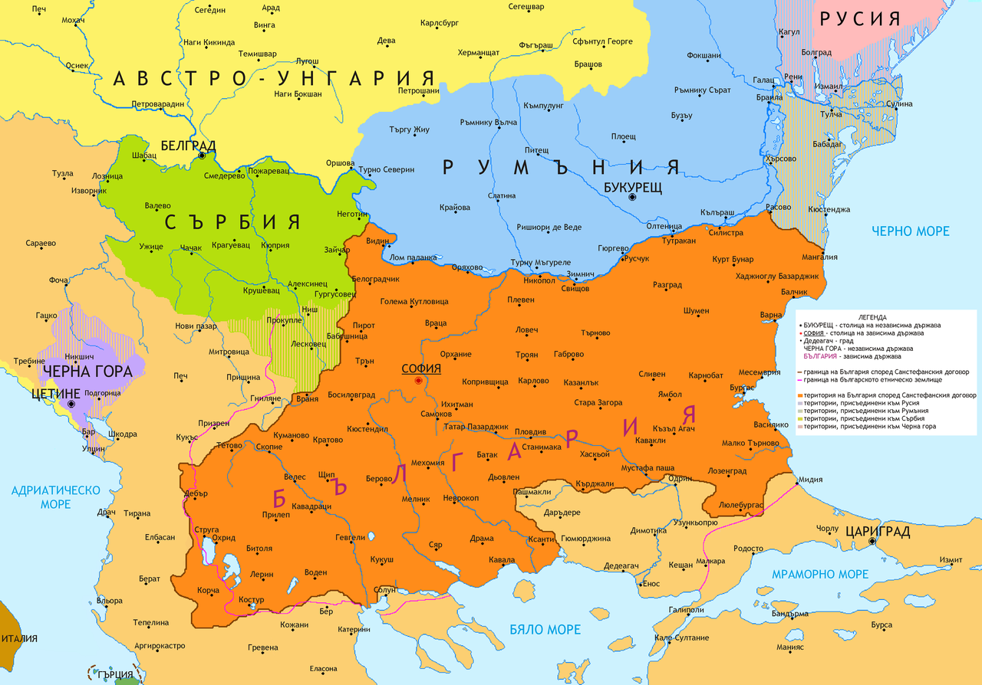
Greater Bulgaria of the 1878 San Stefano Treaty (Source: https://bg.wikipedia.org/wiki/Санстефански_мирен_договор#/media/Файл:Sanstefanska_Bulgaria.png)

Bulgaria’s bookshops and news kiosks are full of commemorative volumes, periodicals and maps of Greater Bulgaria as created by the Russians for four brief months on the basis of the San Stefano (Yeşilköy) Treaty of 3 March 1878. To this day the date is celebrated in Bulgaria with much pomp as the ‘National Day of Liberation.’ However, already on 13 July 1878, in the Treaty of Berlin, the great powers ‘shrank’ the Bulgarian territory to its present-day size, wary of Russia’s growing influence in the Balkans. Most Bulgarians see this development as a ‘national tragedy,’ and still dream of the national ideal of ‘San Stefano Bulgaria.’

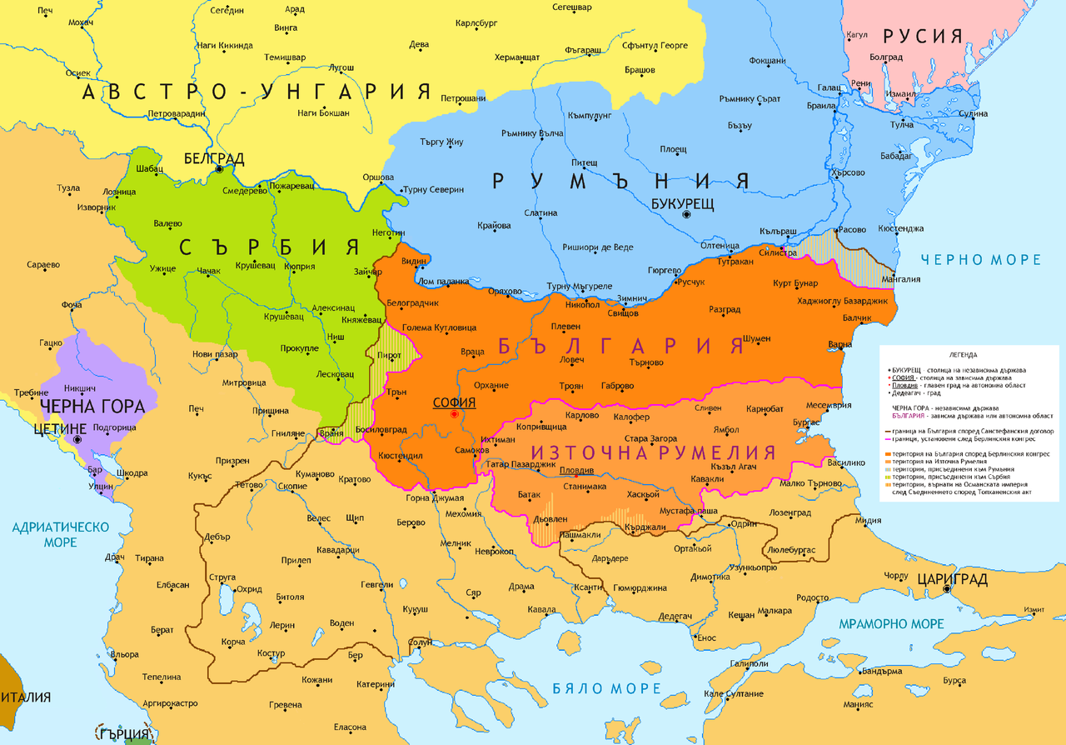
Bulgaria as redefined by the Treaty of Berlin in 1878 (Source: https://bg.wikipedia.org/wiki/Берлински_договор#/media/Файл:Bulgaria_after_Congress_of_Berlin_in_1878.png)

During the First Balkan War, Sofia managed to extend the nation-state’s boundaries considerably for about two months. Another bout of militarily enabled expansion of the Bulgarian territory lasted for three years from 1915 to 1918 during the Great War. Subsequently, the illusory mirage of ‘Greater Bulgaria’ was lost immediately when the Central Powers collapsed, dragging their ally, Bulgaria, down in the defeat. Obviously, the Entente would not hear about any ‘San Stefano Bulgaria.’
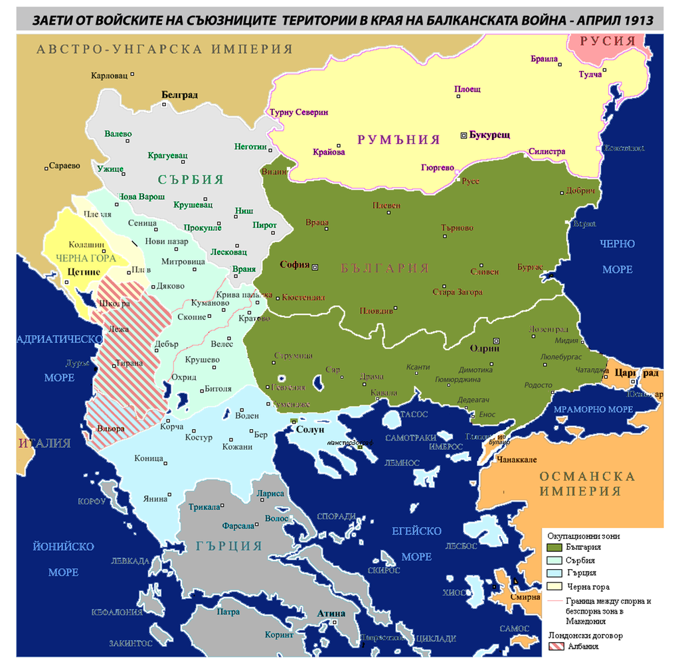
Bulgaria’s territorial gains at the end of the First Balkan War, April 1913 (Source: https://bg.wikipedia.org/wiki/Междусъюзническа_война#/media/Файл:First_Balkan_war_-_liberated_territories_1913.png)

In 1941 Bulgaria joined the Axis Powers’ onslaught against Yugoslavia. As a result, during World War II, Bulgaria managed to regain its ‘true San Stefano borders’ for almost four years. Somehow, from the perspective of present-day Bulgaria, the millions of casualties, refugees and expellees are forgotten. And repeated multi-front warfare against all Bulgaria’s neighbors does not seem to be ‘mad,’ but is lauded as ‘brave tactics’ and ‘patriotism.’ Even worse, the fascist character of Sofia’s alliance with the Third Reich and Mussolini’s Italy is not perceived as a historic liability, nor is Bulgaria’s (oft-denied) active participation in the Holocaust. Bulgarian national ideologues change the past and its interpretations to suit their political needs, while Bulgarian leaders of all political persuasions do not think much about tactically embracing this poisonous politics of remembrance and history, if it can generate votes. Principles do not matter any longer. Again the ‘pragmatism’ of national myths takes over daily lives of people, complete with its well-tested promise of wreaking havoc that politicians are sure to ‘explain away’ as ‘indispensable sacrifice at the altar of the nation.’

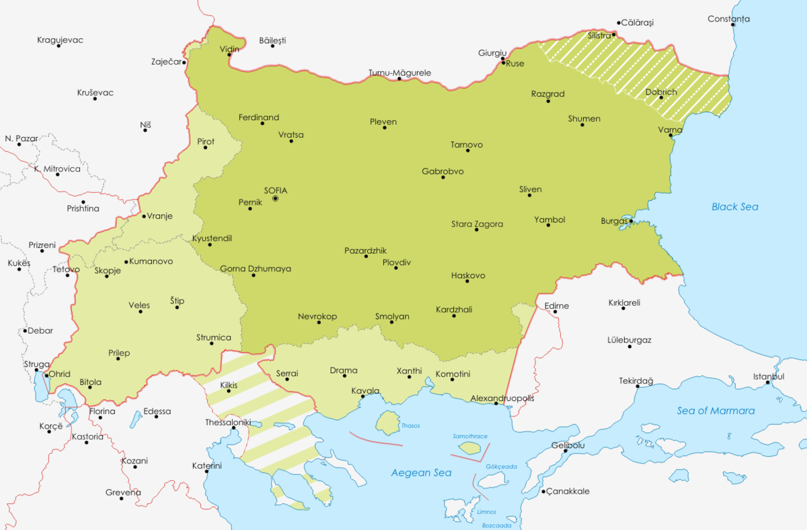
Bulgaria During World War II, 1941-1945 (Source: https://en.wikipedia.org/wiki/File:Map_of_Bulgaria_during_WWII.png)

Bulgaria’s Demands

As in today’s increasingly authoritarian Poland, in Bulgaria the ethnolinguistically defined nation is the most revered totem of collective identity. Many politicians believe that such a nation is ‘by nature’ above the law. The incumbent government expresses the nation’s will and thus can never err or bear being constrained by some international regulations, for instance, the EU’s principles and legislation, or international law. In light of these pro-authoritarian and populist changes in European, Balkan and Bulgarian politics, Sofia’s ultimatum to North Macedonia does not really come as a surprise.

When, for quarter of a century, Greece blocked Macedonia’s aspirations of joining NATO and the EU on the account of the latter country’s ‘wrong’ name, Sofia’s stance appeared to be supportive of Skopje. Somehow Bulgarian politicians could scale any ideological differences that drove the two countries apart during the communist period, when Macedonia was one of communist Yugoslavia’s republics. Promisingly, on 15 January 1992, Bulgaria was the first country to recognize the independence of freshly post-Yugoslav Macedonia. However, the Macedonian Scientific Institute, originally founded in Sofia in 1923 and dissolved in 1947, was re-established in 1990. Its main role was and still is to ‘prove’ the primordial Bulgarianness of Macedonia, and Sofia’s ‘natural right’ to this country. In 1994 this institute issued a memorandum in which, among others, it was claimed that Macedonian is a mere literary variety of the Bulgarian language. This lightly veiled denial of the existence of Macedonian as a language in its own right generated a flurry of agitated diplomatic activity both in Skopje and Sofia. In 1999 a mutually acceptable solution was eventually reached. In essence it fell back on the 1967 Yugoslav-Bulgarian compromise to refer to Bulgarian and Macedonian as ‘official languages’ without the mentioning of any specific glottonyms (language names). In addition, Skopje and Sofia declared that they do not have any claims to each other’s territories, be it on the basis of language or another. Recognizing Bulgaria’s good will, the Macedonian government agreed not to recognize any Macedonian minority in Bulgaria, though such a minority had officially existed in Bulgaria until the Tito-Stalin rift in 1948. The 2017 Friendship Treaty with Bulgaria seemed to be a crowing of this process of scaling differences in favor of a common European future of peace, stability and prosperity.

However, on the side, Bulgarian linguists, with the official support of the Bulgarian Academy of Sciences, continued to equate the ‘Greater Bulgaria’ of the San Stefano Treaty with the ‘true’ territorial extent of the dialectal area of the Bulgarian language. On such a Bulgarian dialectal map one will not find any Macedonian language, or its dialects. The prospect of EU membership for Bulgaria and its subsequent actualization were also deployed for attracting impoverished Macedonians to the Bulgarian nation. Employment and travel opportunities were seriously limited in the case of Macedonia until the breakthrough in the relations with Greece at the turn of 2019. Meanwhile, Sofia did not lose time and offered an easy track to the Bulgarian passport for any willing takers from Macedonia. Thus far, the document has been issued to well over 60,000 Macedonians. This is another ‘argument’ in the eyes of Bulgarian nationalists that Macedonians are ‘Bulgarians suffering the identificational consequences of a denial of their true national identity, as orchestrated by the Yugoslav communists.’

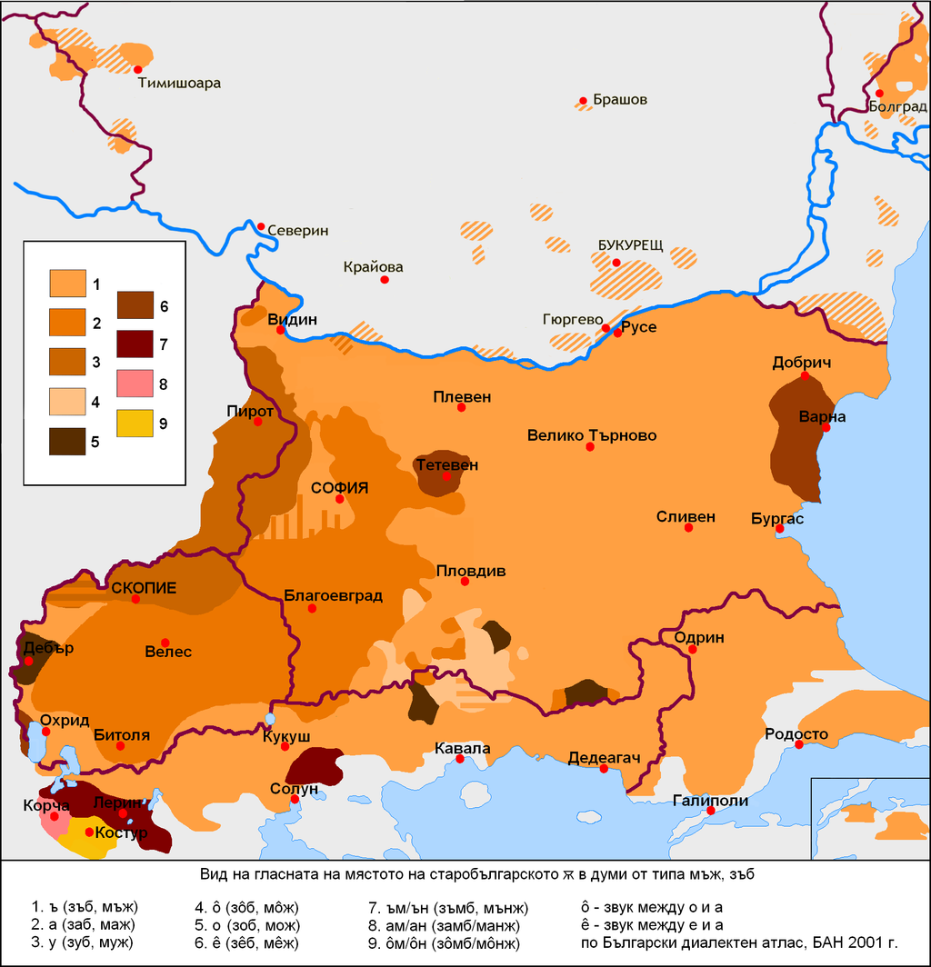
Bulgarian Academy of Sciences’ view on the ‘dialectal territory’ of the Bulgarian language (Source: https://en.wikipedia.org/wiki/Bulgarian_language#/media/File:Bulgarian_dialect_map-yus.png)

Now, with the ultimatum, Sofia threw out of the window the painstakingly achieved and carefully cultivated rapprochement with Macedonia. Instead of extending a helping hand, Bulgaria picks on a weaker neighbor that at present finds itself in the uneasy position of a supplicant. A braver – and ‘patriotically Bulgarian’ – thing to do would be to stand up to Greece, from which Sofia could staunchly demand Aegean Macedonia and western Thrace, as a ‘truly’ Bulgarian province from ‘times immemorial.’ In addition, Sofia does not appear shocked and appalled by the fact that for almost a century Athens has staunchly denied the existence of any Slavic-speaking (Bulgarian or Macedonian) minority in Greece. Should Athens dare not to comply with Sofia’s ultimatum of this kind, Bulgaria could seal off its border with Greece, thus blocking the latter country’s sole direct land access to the rest of the European Union. Who cares that Brussels and Washington would protest? For sure, Russia, as an ‘old and trusted friend’ would come to Sofia’s succor. Bulgaria as an anti-European ‘Trojan horse’ would play nicely in Putin’s larger plan of weakening the EU on the cheap. After all, the Bulgarian nation is above the law, and what really counts is only its interest. In Bulgarian nationalists’ eyes another Balkan war should be seen as nothing more, but a small price to pay for the eventual actualization of the long-yearned-for dream of re-founding ‘San Stefano Bulgaria.’

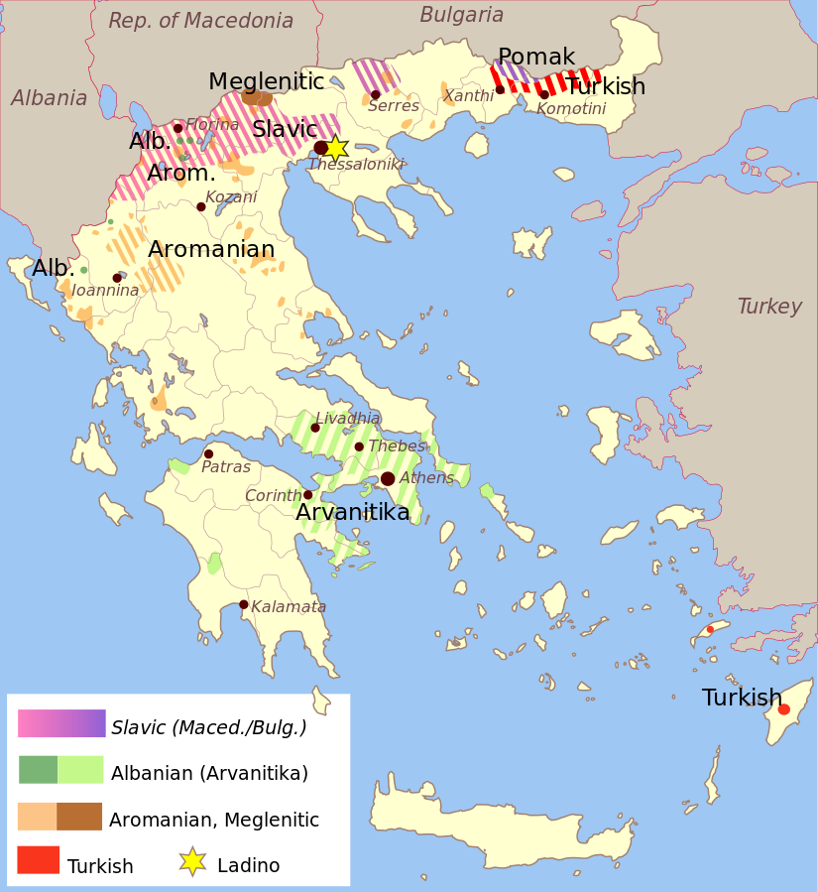
Slavophone (Macedonian / Bulgarian) minority in northern Greece (Source: https://mk.wikipedia.org/wiki/Податотека:Greece_linguistic_minorities.svg)

Somehow Bulgarian leaders and nationalists are not that brave. They are careful not to anger a fellow EU member state. This could cost Bulgaria a loss of its prized membership in the European Union. After all Brussels is the main source of funds for the development of Bulgaria and for lining the pockets of its corrupt politicians. Hence, the ultimatum handed to North Macedonia is a cost-effective and seemingly risk-free manner in which Bulgarian leaders can ‘prove’ their patriotism and loyalty to the nation. For the time being, North Macedonia seems to be the sole loser of the situation that is not of Skopje’s making, while other members of the European Union choose to look away.

The ultimatum’s list of 20 odd demands is impossible to fulfill. By doing so Skopje would have to agree to the utter humiliation of North Macedonia and its citizens. Not only does Sofia want Skopje to refrain from talking about any Macedonian minority in western Bulgaria. North Macedonia is also required not to use the term ‘Macedonian language’ in any international context and especially in the European Union. At best, according to Sofia, it should be referred as a ‘dialect of Bulgarian.’ The old chestnut on the non-existence of the Macedonian nation has been refreshed in Sofia’s demand that in Macedonian history textbooks fascist Bulgaria’s wartime occupation of Macedonia should not be labelled as ‘occupation.’ The reasoning behind it is that the Macedonians are a regional group of the Bulgarian nation, while North Macedonia is part of the ‘Greater Bulgaria’ of 1878. Hence, in 1941 Sofia did not annex, but ‘united’ Macedonians and their ‘region’ with their ‘mother country’ of Bulgaria. To add insult to injury, Sofia wants Skopje to give up on North Macedonia’s most important modern national hero Goce Delčev, who instead is to be recognized as an ‘exclusively Bulgarian hero.’ Recently, in order to up the ante, Bulgarian nationalists, led by MEP Angel Dzhambazki, announced that North Macedonia is none other, but a ‘second Bulgarian state.’

The rhetoric eerily reminds one of the Third Reich’s view of interwar Austria prior to the Anschluß of 1938. Berlin denied the existence of any Austrian nation. From Hitler’s perspective the country’s inhabitants were deemed to belong to the German nation. Hence, Austria was an ‘unnecessary’ second German state in Europe. The Nazis saw the territory of Austria as a ‘German province’ in a dire need of unification with the motherland of Germany. The imposed ‘fulfillment’ of these wishes was one of the causes of World War II. Nowadays, any German politician voicing such odiously anti-Austrian views would be relieved of their post in no time, and Vienna would be sure to protest loudly. In today’s Europe there is no place for any German neo-imperialism, as an entailed World War III would have surely turned the continent into an inhabitable radioactive wasteland. Hence, even far-right extremists and radical nationalists enamored of the German nation would not dream of calling for another annexation of Austria.

At the same time, the Austrians see no problem in sharing the German language with the Germans, Belgians, Liechtensteiners, Luxembourgers and the Swiss. However, none of the aforementioned nations with a stake in this tongue, sees it as an argument for creating a Greater Germany, where all German-speakers would have to be gathered. Hence, Sofia’s insistence that the Macedonians must relent and redefine their language as a dialect of Bulgarian is an ideological throwback from Europe’s dark 20th century. That was the ‘logic’ of Hitler’s ‘Greater German Empire’ (Großdeutsches Reich), as Germany was officially renamed in 1943. Such a ‘logic’ does not become the democratic EU. But when Brussels has kept turning a blind eye to Sofia’s revanchist antics one time too many, the Bulgarian government must have jumped to a conclusion that certainly Bulgaria – as the self-styled oldest civilized country in Europe – must be exempted from observing such petty rules.

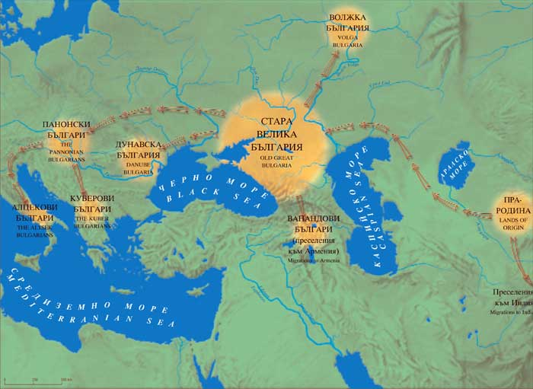
All the Bulgarias of the distant past remade into Sofia’s ‘Bulgarian World’ (Source: http://www.spiralata.net/kratce/index.php/istoriya/1021-balgarskite-darzhavi-predi-681-g)

A similarly imperial approach to language politics was practiced in the late Russian Empire. In 1863 the existence of the Ukrainian language was denied and its use in publishing strenuously banned until 1905. Subsequently, a theory was developed that Belarusian and Ukrainian are not languages in their own right, but mere ‘peasant dialects’ of the single imperial (Great) Russian language. Nowadays, this theory has been revived as part of Russia’s neoimperial ideology of the Russkii Mir (‘Russian World’). In turn, this ideology ‘justifies’ the Kremlin’s annexations in Ukraine and attempts to make Belarus into another Russian province. Sofia appears to be a diligent student of this new-old postmodern politics à la russe. If the Kremlin can aspire to an ever-expanding ‘Russian World,’ Sofia should have its right recognized to a similar Bılgarski sviat (Bulgarian World), which on the ‘historic grounds’ extends at least from the Volga and the Aral Sea in the east to the Danube basin and the Apennine Peninsula in the west.

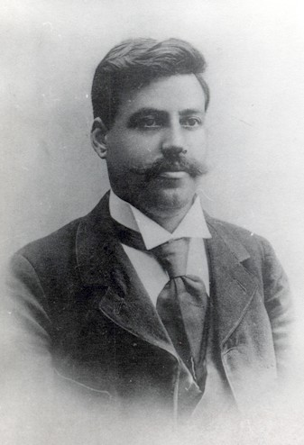
Goce Delčev (Source: https://mk.wikipedia.org/wiki/Гоце_Делчев#/media/Податотека:G_Delchev.jpg)

Goce Delčev – a revolutionary, nationalist, leader, politician and terrorist in one – was born in 1872 in the Ottoman town of Kilikis, which nowadays happens to be located in northern Greece, that is, in Aegean Macedonia. At that time, neither Bulgaria nor Macedonia had been founded as nation-states yet. Delčev wanted to create a nation-state for a postulated nation of Macedonians in order to prevent the partition of Ottoman Macedonia between Bulgaria, Greece and Serbia. Initially, he had some hopes of Bulgarian support for his program, but soon he came to a realization that a ‘San Stefano Bulgaria’ would be no solution to the ‘Macedonian’ problem. In 1903 Delčev died in a skirmish with Ottoman troops. He had no way of knowing that in 1934 Comintern would recognize the Macedonians as a nation in order to thrust a thorn into the side of Belgrade’s policy of Serbianizing its share of Macedonia, known as ‘southern Yugoslavia.’ Ten years later, in 1944, the victorious communist Yugoslav partisans, under Tito’s leadership, granted the Macedonians their own national republic in communist Yugoslavia. Immediately, the Macedonian activists and leaders followed with a Soviet-style program of the accelerated development of Macedonian as a written medium of education, administration, scholarship, literature and culture.

The politics of history is a widely accepted intellectual-cum-political fashion in today’s Europe. Using preselected elements of the past ‘appropriately’ reinterpreted (that is, to a degree falsified) for current needs has become a new norm of political discourse. From this inherently biased perspective, Sofia claims Delčev as a Bulgarian, while Skopje as a Macedonian. On the strength of his place of birth, Athens could claim him as a ‘Greek,’ while Ankara might see him as a ‘disloyal Turk,’ because Delčev was an Ottoman subject. When Yugoslavia thrived, his rewardingly multiethnic and polyconfessional background made Delčev into a ‘true Yugoslav.’ But all such claims are, in essence, anachronistic, and an error of judgement to a historian. The sociopolitical reality in which Delčev lived was largely non-national, and only after his death it was firmly split among ethnolinguistically defined nation-states. Should they like it or not, all these Balkan national polities share their pre-national common past, which cannot be retroactively split along some then non-existent ‘national lines.’

The Bulgarian-Macedonian quarrel over Delčev resembles the debate over the ‘true nationality’ of the romantic poet Adam Mickiewicz (1798-1855). He was born in the Russian Empire to a petty noble family who, in 1795, had experienced the demise of their country, the Commonwealth of the Kingdom of Poland and the Grand Duchy of Lithuania. The family’s and the poet’s lingering loyalty was to this Commonwealth, and especially to the Grand Duchy of Lithuania. However, nowadays Mickiewicz is claimed to be a Polish national poet, because he wrote in Polish, though he never visited the Polish capital cities of Warsaw or Cracow. Others consider Mickiewicz a Lithuanian poet, because he gained education in Vilnius, or the present-day capital of Lithuania. The Belarusians believe that they also have a right to Mickiewicz, because his family mansion is located in today’s Belarus. Many Jews in the diaspora and Israel deem Mickiewicz to be a Jewish poet, too, because of the Jewish origin of this poet’s mother. However, when Mickiewicz died, there was no nation-state going by the name of Belarus, Israel, Lithuania or Poland yet. Hence, all the respective national historiographies have the same claim to their shared common pre-national past of Poland-Lithuania. Obviously, Moscow could see Mickiewicz as a ‘disloyal Russian,’ too, since he was a subject of the tsar, though got engaged in anti-Russian conspirations.

Bulgaria’s Secret Empire

When the European Union looks the other way, seeing to ‘more important’ matters at hand, Sofia busies itself with the underhand – or ‘hybrid’ – reconstruction of ‘San Stefano Bulgaria.’ This project is implemented now at the direct expense of North Macedonia and the future of its citizens, but also undermines European integration in the Balkans, alongside the basic principles of the European Union. Curiously, the EU’s poorest weakest and most corrupt member state is able to wag the entire Union, when no one pays attention. In more ways than one, this Bulgarian approach appears to copy Moscow’s destabilizing tactics as applied to the EU and non-EU countries located along the Union’s eastern frontier. In the immediate postcommunist past, the Kremlin considered this area to be the ‘near abroad,’ or Russia’s exclusive sphere of influence. After 2007 the policy became rebranded under the novel moniker ‘Russian World.’ It is Moscow alone that defines, as it sees fit, the spatial extent of this Russkii Mir. For instance, nowadays, the term seems to cover both Syria and Israel.

By necessity, Sofia’s tacit neoimperial ambitions are more limited. So far, no one officially speaks about any program of a ‘Bulgarian World.’ Yet, it should be asked what Bulgaria’s territorial aspirations may be beyond the ‘near abroad’ of North Macedonia, or this ‘second Bulgarian state’ in the Balkans.

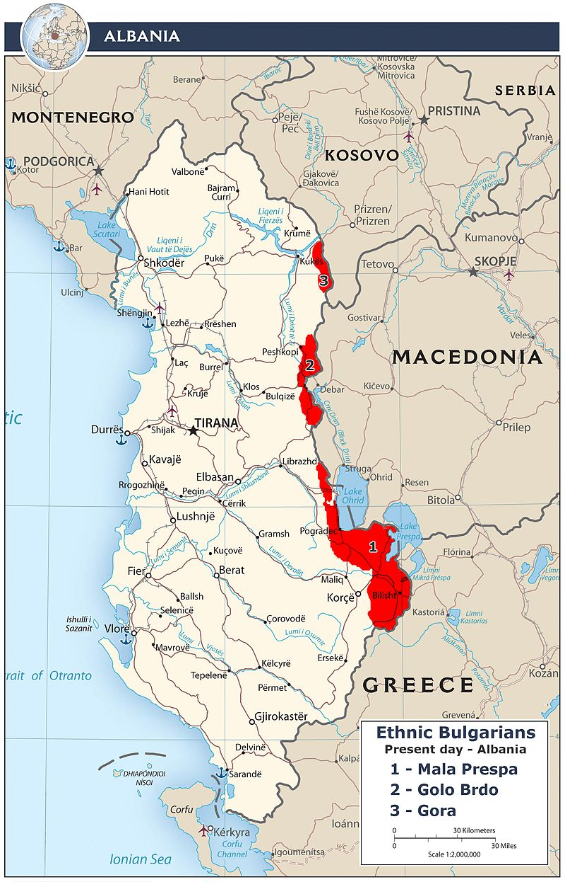
Maximalist view of the Bulgarian minority in Albania (Source: https://bg.wikipedia.org/wiki/Българи_в_Албания#/media/Файл:Ethnic_Bulgarians_In_Albania.jpg)

In return for Sofia’s promise of support in Albania’s efforts to join the European Union, in 2017 Tirana recognized the country’s Orthodox Slavic-speakers as a Bulgarian minority. Strangely, members of this new minority reside along Albania’s frontier with Macedonia. Skopje dislikes this development and considers these Orthodox Slavic-speakers to be Macedonians. But Macedonia has hardly anything to offer to Tirana or to the very minority in question. On the other hand, the latter may now apply for Bulgarian citizenship and receive the much coveted Bulgarian-EU passport, which would allow them to seek gainful employment in the European Union. Remittances sent back home will help both their families and the development of Albania. So the Bulgarian World is already growing, when no one in the European Union is watching. The Bulgarian Prime Minister Boiko Borisov did not fail to curry favor with nationalists by crediting this ‘historic breakthrough’ to his personal diplomatic endeavors. Somehow Sofia’s hybrid policy of reaffirming – through demographic and cultural means – the tacit existence of ‘San Stefano Bulgaria’ on the Albanian territory has escaped the Albanian government’s attention.

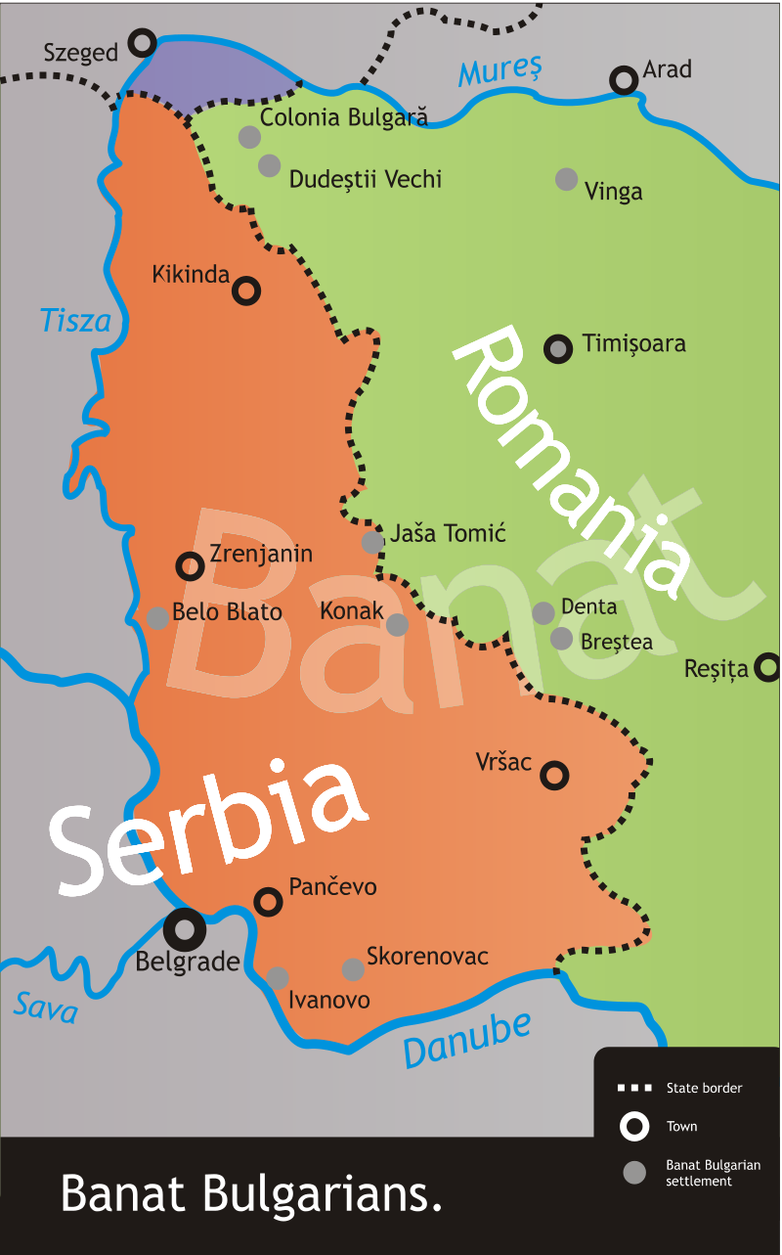
Paulicians or ‘Banat Bulgarians’ (Source: https://en.wikipedia.org/wiki/Banat_Bulgarians#/media/File:Banat_Bulgarian_settlement.svg)

Another diasporic group claimed and lauded by Sofia and Bulgarian scholarship are the ‘Banat Bulgarians,’ though its members prefer to be known as ‘Paulicians.’ Their origin dates back to the period of prolonged intermittent warfare between the Habsburgs and the Ottomans, which ravaged and destabilized much of the northern Balkans. Between the late 17th century and the mid-18th century a trickle of Slavophone Orthodox refugees followed from what today is the northwestern corner of Bulgaria, across the Danube, to the Habsburg lands north of the Danube. Most settled in Banat, which Vienna permanently seized from the Ottomans in 1718. With time these refugees adopted Catholicism and the Latin script for writing their South Slavic vernacular. Books were published in this Paulician language during the 19th century, and its use was revived after the fall of communism. Sofia considers Paulician to be a ‘third literary standard’ of the Bulgarian language, following the Bulgarian and Macedonian literary standards. However, Bulgarian scholars prefer to dub this language ‘Banat Bulgarian.’ In the wake of the breakup of Austria-Hungary, Banat was split between Yugoslavia and Romania. Unlike in the case of Albania’s ‘Bulgarians,’ the prospect of a Bulgarian-EU passport does amount to much among Paulicians. The Romanian-EU passport – also available to Paulicians living in Serbia – offers exactly the same privileges like its Bulgarian counterpart. Hence, Paulicians have no immediate need to cozy up to Sofia.

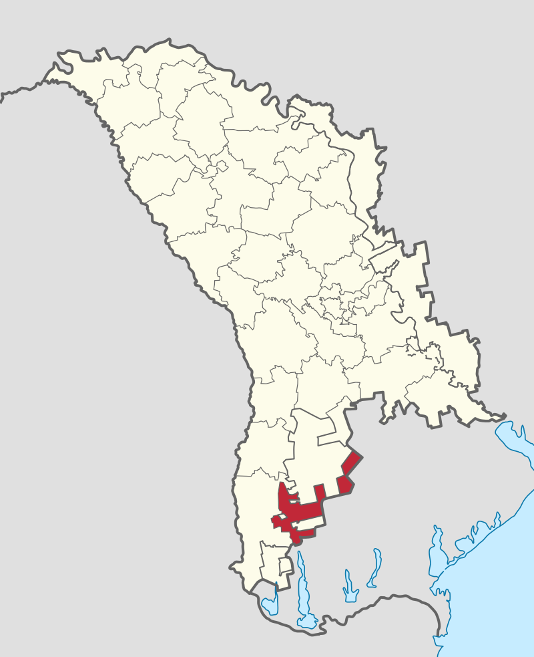
Taraclia County (marked red) in southern Moldova (Source: https://ro.wikipedia.org/wiki/Raionul_Taraclia#/media/Fișier:Taraclia_District_in_Moldova.svg)

However, Sofia’s most interesting and least noticed foray is into Taraclia County in southern Moldova. As a result of the Russo-Ottoman War of 1806-1812, St Petersburg gained Bessarabia (or today’s Moldova). Local Slavophone Orthodox (‘Bulgarian’) supporters of the Russians south of the Danube evacuated with the Russian troops to escape Ottoman reprisals. At present, ethnic Bulgarians, numbering 28,000, add up to two-thirds of the county’s population, while in total, around 65,000 ethnic Bulgarians live across all of Moldova. In 2004, with Sofia’s support, Taraclia State University was founded with Bulgarian as its medium of instruction. Definitely, Moldova being Europe’s second poorest state (after post-2014 Ukraine), a Bulgarian-EU passport is quite an attraction. Already a four-fifths of job active Moldovans work abroad, meaning that almost half of the population de facto emigrated from the country to the EU or Russia. Obviously, a Moldovan citizen can apply for a Romanian-EU passport (half a million already did and obtained this document), but if the Bulgarian authorities make it even easier for Taraclia’s Bulgarians to obtain a Bulgarian counterpart, then why not to take up this offer.

Since the turn of the 21st century, Sofia has supported Taraclia’s Bulgarians in their efforts to win an autonomous status for their county. In 2014 even a bill to this end was lodged with the Moldovan Parliament. Chișinău already has at its plate two autonomous regions, namely, the breakaway Transnistria under de facto Russian control, and Gagauzia for Turkic-speaking Orthodox Gagauzes. More ethnolinguistic autonomous regions of this kind could endanger the very existence of Moldova as a state. Such a development would be only in Moscow’s interest. First, deepening instability would preclude NATO and EU membership for Moldova. And, second, the European Union would have no choice but to deal with any political and economic fallout at its eastern frontier. Fortunately for the Kremlin, the Russian Federation is separated by all of Ukraine from Moldova.

Although Sofia believes that Moldova should grant an autonomous region to Taraclia’s Bulgarians, the Bulgarian authorities have never considered a solution of this kind for Bulgaria’s Turks, who number anything between 600,000 and 1 million, amounting to a tenth of the country’s population. After the postcommunist rapprochement with the previously discriminated Bulgarian Turks, Sofia has consistently shied away from granting a Turkish-medium university to this minority. In Bulgaria there are not even Turkish-medium schools. Any grassroots efforts to this end are regularly and predictably torpedoed by Bulgarian nationalists. At the same time, Taraclia’s Bulgarians enjoy the full Bulgarian-medium educational system as a matter of course. Bulgarian nationalists and politicians concur that a Turkish autonomous region in Bulgaria would inescapably lead to separatism and the eventual breakup of the country. But somehow they do not think that a Bulgarian autonomous region in Moldova could bring about a similarly negative outcome. Is it blindness, double standards or shrewd tactics on the way to a ‘Bulgarian World’ (Bılgarski sviat) from the Dniester to Sofia and from Banat to Skopje?

What if this program would trigger a serious conflict, or let alone, full-fledged war? Perhaps, Sofia trusts, that in such a case, NATO and the EU would come to Bulgaria’s succor. But why should these organizations feel any responsibility for cleaning up the Bulgarian mess? Especially when, on the one hand, Sofia abandons the principles of democracy, rule of law and the freedom of speech, while on the other, Bulgaria flirts with Russia and the Russkii Mir-style way of doing international politics? It is high time that the Bulgarians alone would foot the bill for their Bılgarski sviat and the national delusion of ‘Greater Bulgaria.’

October 2019

I thank Elena Marushiakova, Veselin Popov and Radosveta Vassileva for their advice and suggestions for improvement. Obviously I am responsible for any remaining infelicities. It was Dawid Warszawski’s (a nom de plume of Konstanty Gebert) article ‘Dla kogo Macedonia?’ (2019. Gazeta Wyborcza. 17 Oct. https://classic.wyborcza.pl/archiwumGW/9067006/Dla-kogo-Macedonia-) that inspired me to write this essay.
Cf https://www.euractiv.com/section/enlargement/news/tsipras-and-zaev-reportedly-in-the-running-for-nobel-peace-prize/ ; https://www.bbc.co.uk/news/world-europe-47785258
https://www.rferl.org/a/greece-macedonia-sign-agreement-name-despite-protests/29293265.html
Cf https://en.wikipedia.org/wiki/Mandatory_Swedish
https://www.rferl.org/a/macedonia-s-albanian-language-bill-becomes-law/29711502.html
https://www.academia.edu/39208225/North_Macedonia_A_Surprise
https://www.ft.com/content/eda39e1e-f3eb-11e9-b018-3ef8794b17c6
https://www.euractiv.com/section/future-eu/news/skopje-on-fire-as-meps-slam-eu-leaders-failure-to-open-accession-talks/ ; https://atlanticcouncil.org/blogs/new-atlanticist/by-blocking-enlargement-decision-macron-undercuts-frances-balkan-goals/
https://english.republika.mk/news/macedonia/what-did-you-think-is-going-to-happen-bitter-reactions-in-macedonia-after-bulgaria-presents-an-ultimatum-over-goce-delcev/
https://www.investor.bg/ikonomika-i-politika/332/a/bylgariia-ne-dava-bezuslovna-podkrepa-za-severna-makedoniia-v-es-290287/ ; https://btvnovinite.bg/bulgaria/balgarija-s-uslovija-kam-severna-makedonija-za-chlenstvoto-j-v-es.html
http://www.gov.bg/bg/prestsentar/novini/ramkova-pozitsia ; https://www.vesti.bg/sviat/makedoniia-spored-bylgariia-niama-makedonski-ezik-ili-malcinstvo-6100717
https://www.segabg.com/node/98205
https://en.wikipedia.org/wiki/IMRO_–_Bulgarian_National_Movement
https://www.mediapool.bg/politiko-balgarskata-kraina-desnitsa-shte-raztarsi-bryuksel-news269171.html ; https://www.dnevnik.bg/bulgaria/2019/06/08/3922576_karakachanov_zastana_zad_homofobska_kauza_i_pohod_za/ ; https://balkaninsight.com/2019/02/08/bulgarian-nationalists-issue-controversial-roma-integration-plan-02-07-2019/ ; https://www.theguardian.com/world/2019/oct/20/bulgaria-sofia-racism-roma-everybody-hates-us-anti-gypsy-abuse
https://nova.bg/news/view/2019/09/29/264064/каракачанов-вмро-напуска-властта-ако-подкрепим-северна-македония-за-членство-в-ес
https://www.mediapool.bg/karakachanov-prodalzhava-s-provokatsiite-makedonskite-polititsi-sa-dobri-balgari-news298562.html
https://nova.bg/news/view/2019/10/17/265806/каракачанов-северна-македония-е-по-достойна-за-ссср-отколкото-за-ес
https://www.dw.com/bg/най-голямото-предателство-в-българската-история/a-46815221 ; https://www.24chasa.bg/novini/article/5097382
https://www.mediapool.bg/balgarskata-pozitsiya-za-severna-makedoniya-e-nova-razdelitelna-liniya-news298837.html ; https://www.svobodnaevropa.bg/a/30212052.html
https://www.standartnews.com/balgariya-politika/radev-drzhavata-se-upravlyava-chrez-nechiy-telefon-401755.html ; https://www.dnes.bg/politika/2018/12/07/radev-demokraciiata-v-bylgariia-e-v-kritichno-systoianie.395938
https://telma.com.mk/bugarskiot-pretsedatel-so-nov-ultimatum-do-makedonija/
https://europa.eu/rapid/press-release_IP-19-6033_en.htm ; https://www.theguardian.com/world/2019/sep/16/hungary-faces-eu-disciplinary-action-over-alleged-rule-of-law-violations
http://neweasterneurope.eu/2018/09/27/bulgarias-autocratic-model/ ; http://neweasterneurope.eu/2019/05/21/bulgarias-dangerous-flirtation-with-the-far-right/
https://euobserver.com/opinion/142795 ; https://verfassungsblog.de/is-bulgarias-rule-of-law-about-to-die-under-the-european-commissions-nose-the-countrys-highest-ranking-judge-fears-so/
http://neweasterneurope.eu/2019/09/06/how-many-ministries-of-truth-does-bulgaria-have/ ; http://neweasterneurope.eu/2019/07/17/on-the-price-of-horses-and-the-rule-of-law-in-the-eu/
Cf https://www.nbcnews.com/storyline/europes-border-crisis/bulgarian-vigilantes-patrol-turkey-border-keep-migrants-out-n723481
http://www.boec-bg.com/archives/551
https://pressroom.rferl.org/a/rferl-returns-to-bulgaria/29722317.html ; https://www.usagm.gov/2019/06/13/rfe-rl-formally-relaunches-bulgarian-service/
https://reutersinstitute.politics.ox.ac.uk/our-research/age-oligarchs-how-group-political-and-economic-magnates-have-taken-control-bulgaria
Cf https://www.realclearworld.com/2019/10/12/for_eastern_europe_brussels_is_the_new_moscow_200379.html ; https://www.dw.com/bg/ес-ссср-нека-да-видим/a-47189642
https://bg.rbth.com/history/330434-varshavski-dogovor-suvetskata-versiya-na-nato
http://bulgarianpresidency.eu/bulgaria-no-longer-considered-consolidated-democracy/ ; https://www.sbs.com.au/language/english/audio/bulgarians-prefer-authoritarian-rule-to-democracy
https://www.economist.com/briefing/2018/02/03/europes-populists-are-waltzing-into-the-mainstream ; https://www.segabg.com/node/86802
http://neweasterneurope.eu/2019/02/25/words-matter-bulgaria-and-the-30th-anniversary-of-the-largest-ethnic-cleansing-in-cold-war-europe%ef%bb%bf/
https://bg.wikipedia.org/wiki/Атака_(партия)
https://www.opendemocracy.net/en/can-europe-make-it/whats-left-when-you-are-far-right-in-bulgaria-0/
https://foreignpolicy.com/2019/01/25/theres-one-country-in-europe-where-putin-is-a-rock-star-russia-serbia-vucic-belgrade-kosovo/
Cf https://www.independent.co.uk/independentminds/long-reads/bulgaria-russia-moscow-kremlin-influence-oligarchs-nato-us-west-cold-war-a8864136.html ; https://www.politico.eu/article/bulgarian-far-right-set-to-shock-brussels/ ; https://foreignpolicy.com/2019/10/11/eastern-europe-eu-brussels-soviet-union-moscow/
http://neweasterneurope.eu/2018/09/07/bulgaria-unlikely-personality-cult/
http://neweasterneurope.eu/2019/09/17/eu-flags-for-balkan-tyrant-and-ethnic-cleanser/
https://en.wikipedia.org/wiki/Annexation_of_Crimea_by_the_Russian_Federation
https://en.wikipedia.org/wiki/Budapest_Memorandum_on_Security_Assurances
https://www.rferl.org/a/russia-sanctions-timeline/29477179.html
https://en.wikipedia.org/wiki/Helsinki_Accords#Articles
The Kremlin claims that it was the west, which breached the Helsinki Accords first in 2008 by recognizing the independence of Kosovo. However, it was Serbia that had originally attacked and expelled Kosovo’s Albanian-speaking majority. In Crimea the Ukrainian authorities neither suppressed, let alone expelled the peninsula’s Russophones (Cf https://www.foreignaffairs.com/articles/russia-fsu/putin-s-propaganda ; http://www.stoletie.ru/vzglyad/kto_pohoronil_khelsinkskije_soglashenija_688.htm ; https://ruxpert.ru/Вопрос_о_независимости_Косово#.D0.9F.D0.BE.D0.B7.D0.B8.D1.86.D0.B8.D1.8F_.D0.A0.D0.BE.D1.81.D1.81.D0.B8.D0.B8 ; http://www.odnako.org/blogs/helsinkskiy-lohotron-o-nerushimosti-granic-kotoruyu-dolzhna-soblyudat-tolko-rossiya/)
Cf http://secure.ditchley.co.uk/conferences/past-programme/2010-2019/2015/european-security ; https://www.rferl.org/a/rip-helsinki-accords/27161370.html
https://www.rferl.org/a/serbia-s-vucic-says-no-recognition-of-kosovo-unless-belgrade-gets-something-too/29803920.html
https://balkaninsight.com/2019/10/25/serbia-signs-trade-deal-with-russias-eurasian-union/
https://en.wikipedia.org/wiki/Brexit
https://www.express.co.uk/news/politics/1189999/Brexit-news-Boris-Johnson-UK-EU-deal-Commons-speech-European-Union
https://www.irishtimes.com/news/world/europe/welcome-to-bulgaria-the-world-s-fastest-shrinking-nation-1.3658819
https://financialobserver.eu/recent-news/bulgaria-remains-the-most-corrupt-country-in-eu/ ; https://www.theguardian.com/world/2017/dec/28/bulgaria-corruption-eu-presidency-far-right-minority-parties-concerns
https://www.novinite.com/articles/171684/More+Bulgarians+Working+Abroad+Than+in+Bulgaria ; https://www.24chasa.bg/novini/article/5097621
https://en.wikipedia.org/wiki/Treaty_of_San_Stefano
https://royalcentral.co.uk/europe/simeon-ii-of-bulgaria-attends-national-day-celebrations-in-sofia-117172/ ; https://www.novinite.com/articles/195546/Bulgaria+Celebrates+the+Day+of+Liberatio
https://en.wikipedia.org/wiki/Treaty_of_Berlin_(1878)
https://www.webcafe.bg/lifecafe/istoriya/id_299080677_Sanstefanska_Bulgaria_i_nesluchiliyat_se_natsionalen_ideal
https://en.wikipedia.org/wiki/Treaty_of_London_(1913)
https://en.wikipedia.org/wiki/Bulgaria_during_World_War_I
https://en.wikipedia.org/wiki/Military_history_of_Bulgaria_during_World_War_II
https://balkaninsight.com/2017/03/10/controversy-sparks-over-bulgaria-holocaust-commemoration-03-09-2017/
Cf https://jacobinmag.com/2019/10/bulgaria-fascism-nazism-anticommunism-historical-memory
Cf https://www.the-american-interest.com/2017/05/01/worshipping-at-the-altar-of-the-nation/ ; https://philevents.org/event/show/2402 ; https://helda.helsinki.fi/bitstream/handle/10138/158351/Soldier%27s%20Death%20and%20the%20Logic%20of%20Sacrifice.pdf?sequence=1
https://www.culturalsurvival.org/publications/cultural-survival-quarterly/ethnic-identities-making-case-bulgaria ; http://www.desant.net/show-news/50985
Cf https://wpolityce.pl/polityka/273101-kornel-morawiecki-w-sejmie-nad-prawem-jest-dobro-narodu-prawo-ktore-nie-sluzy-narodowi-to-bezprawie-reakcja-owacja-na-stojaco-wideo
https://en.wikipedia.org/wiki/Macedonia_naming_dispute
Dejan Marolov. 2013. Republic of Macedonia Foreign Policy: Diplomacy in the Middle of the Balkans. Newcastle upon Tyne: Cambridge Scholars Publishing, p 58.
https://en.wikipedia.org/wiki/Macedonian_Scientific_Institute
https://www.rferl.org/a/1090545.html
Trajko Stamatoski. 2001. Vo odbrana na makedinskiot literature jazik. Skopje: Kultura, pp 141-156.
https://balkaninsight.com/2018/01/15/macedonia-approves-landmark-friendship-treaty-with-bulgaria-01-15-2018/
S Stoikov, S B Bershtein and I Kochev, eds. 2001. Obobshtavasht tom (Ser: Bılgarski dialekten atlas, Vol 4). Sofia: Knigoizdatelska kıshta Trud.
https://balkaninsight.com/2011/12/29/7-000-macedonians-obtain-bulgarian-passports-in-one-month/ ; https://www.novinite.com/articles/199223/More+and+more+Macedonians+Are+Receiving+Bulgarian+Passports ; https://www.mediapool.bg/blizo-30-000-makedontsi-sa-vzeli-balgarski-pasport-za-6-godini-news280737.html ; https://www.dw.com/bg/македонци-българският-паспорт-е-унижение/a-37914463
http://m.focus-news.net/?action=opinion&id=28893 ; https://news.bg/bulgaria/nyama-makedonska-natsiya-predi-1944-g-otseche-dzhambazki.html ; https://news.bg/int-politics/makedonskata-natsiya-e-izmislena-v-kraya-na-vsv-priznaha-v-skopie.html
Cf https://www.24chasa.bg/novini/article/7704580
https://en.wikipedia.org/wiki/Aegean_Macedonia
https://bg.wikipedia.org/wiki/Българи_в_Гърция
https://www.dnevnik.bg/sviat/2019/02/26/3396332_bi_bi_si_razgnevi_gurciia_s_material_za_nevidimoto/ ; https://frognews.bg/kultura/art-jungla/pesnata-dedo.html
https://www.bbc.co.uk/news/stories-47258809 ; https://www.loc.gov/law/help/greece-minorities/greece.php ; https://www.hrw.org/sites/default/files/reports/GREECE945.PDF
Cf https://www.dnevnik.bg/bulgaria/2018/10/16/3328466_ruskoto_vliianie_v_bulgariia_e_prichinata_stranata_da/ ; https://www.dw.com/bg/путин-и-неговите-емисари-в-българия/a-50445451
https://www.minfin.bg/bg/73
https://www.investigativejournalismforeu.net/projects/misuse-of-eu-funds-in-romania-and-bulgaria/ ; https://duma.bg/balgariya-e-darzhava-s-korumpirani-upravnitsi-n192112 ; https://www.dw.com/bg/българинът-се-възмущава-но-продължава-да-търпи/a-49133023
https://balkaninsight.com/2019/10/11/intellectuals-condemn-bulgarias-unacceptable-demands-of-north-macedonia/ ; https://english.republika.mk/news/macedonia/petition-condemns-bulgarias-conditions-laid-on-macedonia/ ; http://umdiaspora.org/2019/10/03/bulgariasmacedoniansyndrome/ ; https://english.republika.mk/news/macedonia/macedonian-and-bulgarian-historians-fail-to-find-common-ground-during-their-ohrid-round-of-talks/ ; https://www.dw.com/bg/какво-точно-иска-българия-от-северна-македония/a-50790983 ; https://lupa.bg/news/borisov-otiva-pri-prezidenta-radev-za-da-bistryat-chlenstvoto-na-severna-makedoniya-v-es_24774news.html
https://english.republika.mk/news/macedonia/bulgarian-nationalist-mep-declares-macedonia-the-second-bulgarian-state-in-the-balkans/
https://de.wikipedia.org/wiki/NS-Staat
https://www.kvantov-prehod.org/article/1106/най-древната-цивилизация-в-европа-е-процъфтяла-на-територията-на-българия-и-част-от-балканите ; https://trud.bg/защо-българия-е-най-старата-държава-в-е/ ; https://www.168chasa.bg/article/5661512
https://uk.wikipedia.org/wiki/Валуєвський_циркуляр
https://visegradinsight.eu/free-belarus/ ; http://neweasterneurope.eu/2019/08/07/after-ukraines-new-language-law-it-is-high-time-for-ukrainian-russian/ ; http://neweasterneurope.eu/2018/02/09/russian-re-ethnicisation-pluricentrism/
https://en.wikipedia.org/wiki/Russian_military_intervention_in_Ukraine_(2014–present)
https://en.wikipedia.org/wiki/Union_State ; https://www.themoscowtimes.com/2019/01/29/a-brotherly-takeover-could-russia-annex-belarus-op-ed-a64326
http://www.spiralata.net/kratce/index.php/istoriya/1021-balgarskite-darzhavi-predi-681-g
https://en.wikipedia.org/wiki/Gotse_Delchev
https://en.wikipedia.org/wiki/Resolution_of_the_Comintern_on_the_Macedonian_Question
https://en.wikipedia.org/wiki/History_of_North_Macedonia#1944–1949
https://en.wikipedia.org/wiki/Macedonian_language#/media/File:Reseniie_na_asnom_za_jazik.jpg ; https://en.wikipedia.org/wiki/Standard_Macedonian ; https://en.wikipedia.org/wiki/Blaže_Koneski#Work_on_standard_Macedonian
https://en.wikipedia.org/wiki/Adam_Mickiewicz
https://www.academia.edu/40019262/Mickiewicz_and_the_Holocaust_An_Alternative_History ; https://www.repozytorium.uni.wroc.pl/Content/66136/19_Michal_Urbanczyk.pdf
https://ru.wikipedia.org/wiki/Ближнее_зарубежье ; https://www.telegraph.co.uk/news/2019/10/23/post-brexit-britain-has-vital-role-play-bringing-nato-back-together/
https://en.wikipedia.org/wiki/Russian_world ; https://en.wikipedia.org/wiki/Geographical_distribution_of_Russian_speakers
https://en.wikipedia.org/wiki/Russian_involvement_in_the_Syrian_Civil_War ; https://en.wikipedia.org/wiki/Russian_Jews_in_Israel
https://exit.al/2017/10/kerkesat-e-ke-pakica-bullgare-ne-shqiperi-do-te-njihet-si-minoritet/
https://news.bg/int-politics/makedonets-v-albaniya-vazmuten-ot-genotsid-s-priznavaneto-na-balgarskoto-maltsinstvo.html ; https://www.mkd.mk/makedonija/politika/kovachev-priznavanjeto-bugarsko-malcinstvo-vo-albanija-ne-ja-zagrozuva ; https://infomax.mk/wp/македонците-против-побугарчување-ма/
https://news.bg/int-politics/priznaha-balgarskoto-maltsinstvo-v-albaniya.html ; https://en.wikipedia.org/wiki/Bulgarians_in_Albania
https://btvnovinite.bg/bulgaria/rekorden-broj-kandidati-za-balgarsko-grazhdanstvo.html ; https://dariknews.bg/novini/sviat/v-albaniia-zaradi-bylgarski-pasporti-edno-selo-se-prevryshta-v-prizrachno-2035708
https://www.mediapool.bg/albaniya-prizna-balgarskoto-natsionalno-maltsinstvo-news270490.html
https://en.wikipedia.org/wiki/Banat_Bulgarians
https://en.wikipedia.org/wiki/Banat_Bulgarian_dialect ; https://www.academia.edu/9202432/ЕЗИКЪТ_НА_БЪЛГАРИТЕ_КАТОЛИЦИ_ОТ_РУМЪНСКИ_БАНАТ_В_НАЧАЛОТО_НА_21_ВЕК
Cf http://www.radiotimisoara.ro/2016/12/21/povestea-romanilor-din-serbia-care-vor-sa-obtina-cetatenia-romana/ ; http://www.jurnalromanesc.ro/jr2/index.php/component/k2/115-boljevac/1038-apel-privind-acordarea-cetateniei-romane-in-serbia.html
https://bg.wikipedia.org/wiki/Тараклия ; https://bg.wikipedia.org/wiki/Бесарабски_българи
https://ro.wikipedia.org/wiki/Raionul_Taraclia
https://en.wikipedia.org/wiki/Bessarabian_Bulgarians#Modern_Moldova
https://bg.wikipedia.org/wiki/Тараклийски_държавен_университет ; https://tdu-tar.md/ ; http://news.bnt.bg/bg/a/tarakliyskiyat-drzhaven-universitet-chestva-15-godini
https://www.worldatlas.com/articles/the-poorest-countries-in-europe.html ; https://www.the-american-interest.com/2019/07/02/the-fight-for-the-poorest-country-in-europe/
https://en.wikipedia.org/wiki/Emigration_from_Moldova ; https://www.euractiv.com/section/economy-jobs/news/economic-woes-abroad-hit-moldovas-migrant-workers/ ; https://narratively.com/the-country-that-was-orphaned-by-emigration/
http://www.rgnpress.ro/rgn_18/categorii/politic/30986-2019-07-29-08-19-02.html
https://btvnovinite.bg/predavania/tazi-sabota-i-nedelia/besarabski-balgarin-v-moldova-balgarskoto-grazhdanstvo-se-prodava-kato-kartof-na-pazara.html ; https://news.bg/world/i-sred-besarabskite-balgari-posrednitsi-sabirat-pari-za-balgarsko-grazhdanstvo.html
http://news.bbc.co.uk/1/hi/world/europe/261712.stm ; https://news.bg/int-politics/balgarite-v-moldova-poiskaha-avtonomiya.html
https://jamestown.org/program/moldova-risks-opening-pandoras-box-with-national-cultural-districts/
https://www.refworld.org/docid/516fa91e4.html
https://www.president.bg/news5135/prezidentat-radev-poluchi-uverenie-ot-moldovskiya-si-kolega-da-se-zapazi-statutat-na-naseleniya-s-balgari-tarakliyski-rayon.html?lang=bg&skipMobile=1 ; https://offnews.bg/politika/moldova-dava-osoben-statut-na-taraklia-485006.html ; https://trud.bg/молдова-увери-че-ще-запази-статута-на-н/
https://frognews.bg/glasat-na-jabata/glasat/avtonomiia-smesenite-raioni-ima-takav-serial.html ; https://petel.bg/Manifest-v-neta--Balgarskite-turtsi-iskat-granitsi-na-kartata-na-Balgariya--flag-i-himn__86358
https://bg.wikipedia.org/wiki/Турци_в_България
http://www.desant.net/show-news/24584 ; https://novini.bg/bylgariya/obrazovanie/65956?comment=new&page=1
http://imir-bg.org/wp-content/uploads/2014/01/Obrazovanie-na-malcinstvata_2.pdf ; https://yurukov.net/blog/2013/faktite-za-turskiq-ezik-v-uchilishata/ ; https://sofiaglobe.com/2019/05/12/bulgaria-summons-turkish-ambassador-over-reported-call-to-encourage-study-of-turkish-language/ ; https://fakti.bg/bulgaria/379997-turskiat-poslanik-poiska-izuchavane-na-turski-ezik-v-balgarskite-uchilishta ; https://novini247.com/novini/v-balgariya-nyama-turski-uchilishta-turski-avtori-ne-sa-vklyucheni_922039.html
https://www.actualno.com/education/kmetove-iskat-turski-ezik-v-uchilishte-news_664557.html
https://www.actualno.com/politics/djambazki-njama-da-ima-zadyljitelen-turski-v-uchilishtata-ni-dps-dejstva-v-sinhron-s-ankara-news_748737.html
https://bg.wikipedia.org/wiki/Българи_в_Молдова#Учебни_заведения
https://www.dnes.bg/politika/2019/03/27/mestan-poiska-priznavane-na-tursko-malcinstvo.405760 ; http://epicenter.bg/article/-Prez-1990-a-Balgariya-be-na-praga-na-paguben-etnicheski-konflikt-/89370/11/33 ; https://blitz.bg/goreshtite-novini/stsenariy-bitkata-zapochva-ot-rodopite-turtsiya-iskala-avtonomiya-na-krdzhali_news383644.html
Cf http://www.mn.mk/komentari/8650 ; https://daily.mk/vesti/mpc-ohridska-arhiepiskopija-video-3?what=7815839
Cf https://www.dw.com/bg/турското-робство-руските-освободители-и-други-легенди/a-48962900 ; https://www.dw.com/bg/санстефанските-митове-и-българските-комплекси/a-15781481 ; https://bulgarianhistory.org/sanstefanska-bulgaria/ ; https://bg.wikipedia.org/wiki/Велика_България_(политическа_концепция)#Крах_на_Великобългарската_доктрина

