Burn the witch
Trajan Zec* | 28/11/2013

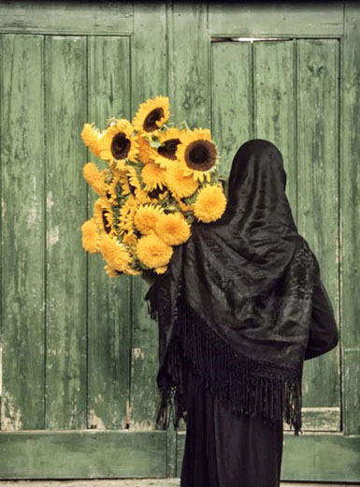
Sir Bedevere: Tell me, what do you do with witches?
Crowd: Burn, burn them up!
Sir Bedevere: And what do you burn apart from witches?
Villager: More witches!
Monty Python and the Holy Grail
If we were to conduct a small survey amongst our closest friends, like-minded people, the reasonable part of this country, and ask them what their opinion is about Sonja Biserko testifying in the case of Croatia vs. Serbia – as a witness of the Croatian side, what do you think that people would say?
I believe that the dull silence also present on the Pescanik website offers an answer to this question. On one side, Vecernje novosti, Informer, Politika (with special editorial attention of Ms. Smajlovic), Pecat, B92, Nasi, Obraz,1389, Blic (which favors the opposition parties) – dear God – everyone agrees that the traitor has finally shown her true face. Thanks to this testimony, everything Biserko did since the nineties has been brought together into one logical whole. She was always against Serbia, she advocated for the Ustashas, the bombing of Serbia, she gobbled infants, worked for the CIA and the Vatican, not to mention the Albanians.
On the other hand, those of who got it in our heads that we are better than those mentioned above – are silent. And why are we silent? Maybe because, to some extent, we agree with the national consensus. We believe that this is wrong, a move against one’s own country, an unpatriotic act. Of course, we are not in favor of stripping Biserko of her citizenship, or deporting her from Serbia, nor do we believe she should be shot in the street like that other communist Stambolic. No, we do not condone such methods. At the same time, we don’t seem to be upset by the fact that an adult citizen of our country cannot step outside her house for two weeks. After all, that’s her problem. If she wants to take full advantage of her civil rights, she should pay more attention to the blood pressure of the average Serb.
We, the good people, do believe that certain red lines which cannot be crossed must exist.
Today, in Serbia, you are not allowed to disagree with Vucic. You are not even allowed to say that the sovereign right of every free individual is to appear before an international court and offer his or her testimony.
Naturally, nobody has asked the question what her statement would actually include. It is taken for granted that she will say how 7.2 million citizens of Serbia are guilty for the war in Croatia, that we were all there showering tanks with roses and sending our children to war.
To me, this looks like a test for a democratic and free society, which should not allow public lynching under any conditions, since the public call for vengeance in the society like our own has, on more than one occasion, ended in real vengeance. This is also a test for a certain Liberal Democratic Party. Naturally, I am not referring to the party leader and mountain climber Cedomir Jovanovic – but, where is Bojan Djuric, for example? Better not to ask.
Year two of the rule of Vucic brings significant harmonization both on the “left” and the right end of the spectrum: LDP and SNS, SPO and SNS, LSV and SNS, and soon – DS and SNS. They are all on the same list, with apostle Vucic in the fore. And then, thanks to Sonja Biserko, we have been given the chance to raise the level of national unity. The only thing left to decide is what to seize from Sonja and in what way. For starters, we should most certainly seize her passport, inquire if she receives a pension, maybe owns a residence? Confiscate it all, ask the SASA for legal advice (for the sake of legality), while the Faculty of Law looks into the laws of the Nazi Germany from the thirties. The results should be published in Vecernje novosti. Naturally, since this is a country of civilized people, we will most certainly not go beyond these administrative measures. After all, this is not a country of violent people. This is a country where conflicts are traditionally resolved in a peaceful manner.
And, to conclude, a segment from Vecernje Novosti (November 22, 2013), written by Miroslav Svircevic from the SANU Institute for Balkan Studies. His ideas are great and surpass the abovementioned administrative measures:
How America Does It
The American poet Ezra Pound was an honored guest of Mussolini in the thirties. He even worked on one popular Italian radio station, where he became an advocate of the fascist propaganda. In 1943, the US administration accused him of treason. Italian partisans handed him over to the US Army in Genoa, and they treated him like a true prisoner of war. However, he was never indicted, nor did he stand trial. He was declared mentally incompetent, which automatically implied the lack of criminal responsibility. Naturally, I am not calling for any kind of violence against Ms. Biserko, but I am only drawing attention to what her fate would be if she were a US citizen and if she chose to work against the interests of her country.
*pseudonim
Translated by Bojana Obradovic
Peščanik.net, 28.11.2013.

