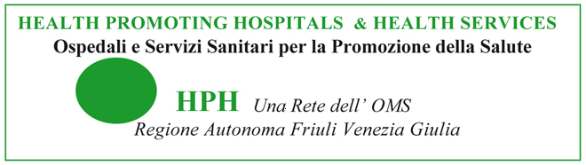 | 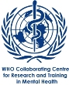 |  | 

Visit 18-20 December 2013
Trieste Mental Health Services / WHO Collaborating Centre

Wednesday 18 December
09.00-11.00 am
Direction of the Mental Health Department - former psychiatric hospital, via Weiss n 5
The Process of De-Institutionalisation and the issue of Forensic Hospital.
Assunta Signorelli
11.00-13.00 am
No Restraint in Healthcare System.
Livia Bicego
The Elderly People Services and the Nursing Homes.
Carlotta Baldi

13.00 – 15.00 Lunch break
If you like you can have lunch at “Il posto delle fragole”
Café-Restaurant of the Social Cooperative - former psychiatric hospital
via de Pastrovich n 4

15.00-17.00 pm
SAR (Padiglione M), via de Pastrovich n 1
Rehabilitation and Residential Unit - Residential Facilities and Social Cooperatives.
The former Psychiatric Hospital – information about its current use for the community.
Rights and Work.
Roberto Colapietro

Thursday 19 December
09.00-13.00 am
CMHC n. 2 Maddalena, via Molino a Vento n 123
Visit to a Community Mental Health Centre: the Process of Care in the Community, from crisis intervention to personalised plans.
Benedetto Capodieci

13.00 – 15.00 Lunch break

15.00-16.30 pm
SPDC, Ospedale Maggiore, via Pietà n 2
Visit to the Emergency Unit.
Daniela Babich

If you like you can have a coffee at Bar Caffè “Piazza Verdi”
Café-Restaurant of the Social Cooperative at “Teatro dell'Opera”.

Friday 20 December
09.00- 13.00 am
CMHC n. 3 Domio, via Morpurgo n 7
Visit to a Community Mental Health Centre, the Programme of “Intervention into the Jail ”.
Alessandra Oretti

13.00 – 15.00 Lunch break

15.00-17.00 pm
CMHC n. 1 Barcola, viale Miramare n 111
Social work and Advocaty (Supported Administration).
Luca Cella
The role of WHO-CC. Final discussion and plans of collaboration.
Roberto Mezzina

