Training for Young Politicians
Agora and Helsinki Committee for Human Rights in Serbia
December 11, 2019, Human Rights House, Belgrade
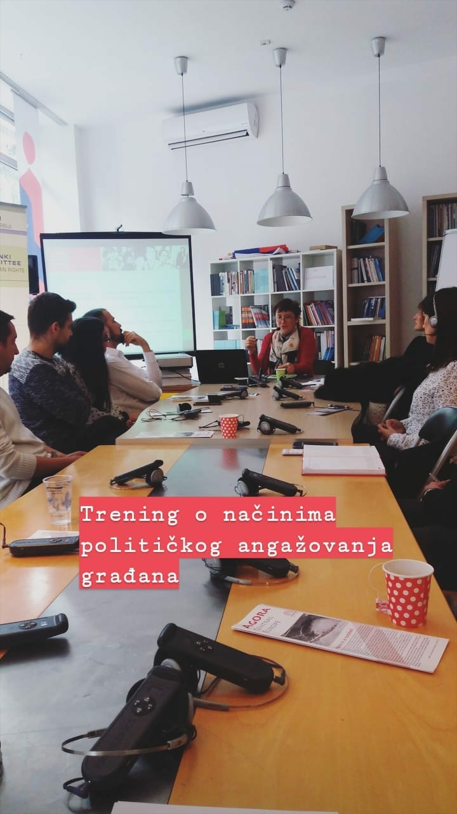
The training on the citizens’ participation in the local level decision-making processes was held on December 11, 2019, in the Human Rights House in Belgrade.
The participants in the workshop were representing the organizations Pokret slobodnih građana, Kritička masa građanski front, Lokalni front Valjevo, and one high-school teacher. They came from Belgrade, Smederevo, Kula, Valjevo, Smederevska Palanka, and Kragujevac.
The trainer Ivana Buriskova from Agora presented the work of the organization she is leading, as well as the political system in Czechia. Already then, at the very beginning of the training, a discrepancy between the current political situation in Serbia and the one in Czechia became apparent.
Later on, during the workshop, the discussion tackled the actual possibilities and tools of citizen’s interaction in local decision-making processes. Serbian participants found it hard to identify with some of the Czech examples of citizen’s activism. The participants were evidently discouraged by various actions of local and central governance in Serbia. They started analysing all the blockades and impossibilities to make some changes in Serbia, since, as they said, they already tried exactly the same measurements, tools and strategies as the trainer’s examples, but unfortunately without any results. The Participants then spoke about other, more successful actions of their organisations, such as mass protests ongoing throughout Serbia since
Discussing the issue of public debates, participants pointed to the fact that Serbia lacks sincere culture of debate. The main cause for that, according to them, were members of the ruling coalition who refuse to take part in these debates if they are to take place with the opposition leaders.
The training ended with practical advices of the trainer on how to organise, start, and implement a successful public debate.

